Hands On 14: **Solution**

Deploying the image on to ECS

1. Right click on the Project in the solution explorer and choose “Publish Container to AWS” and from the dropdown choose “Run Task on ECS Cluster”.

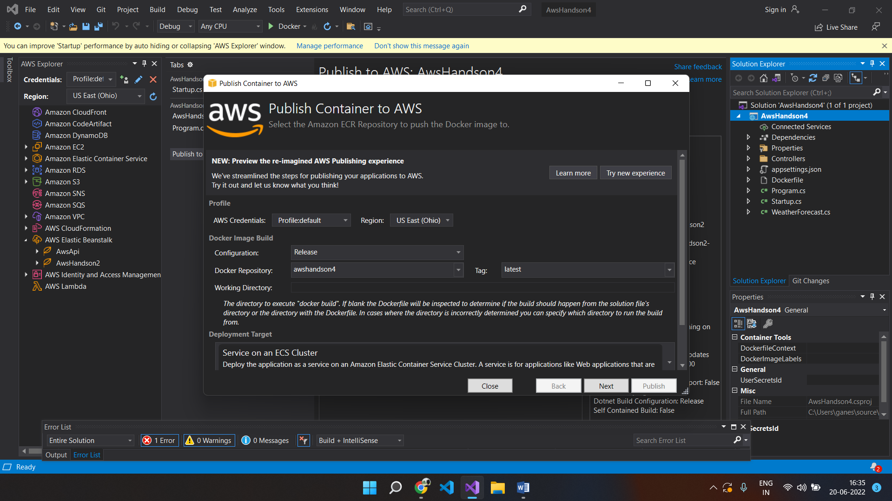

1. Next Screen will prompt us to create a new cluster and give a name to the cluster and choose launch type as “Fargate” as shown in the below screen.

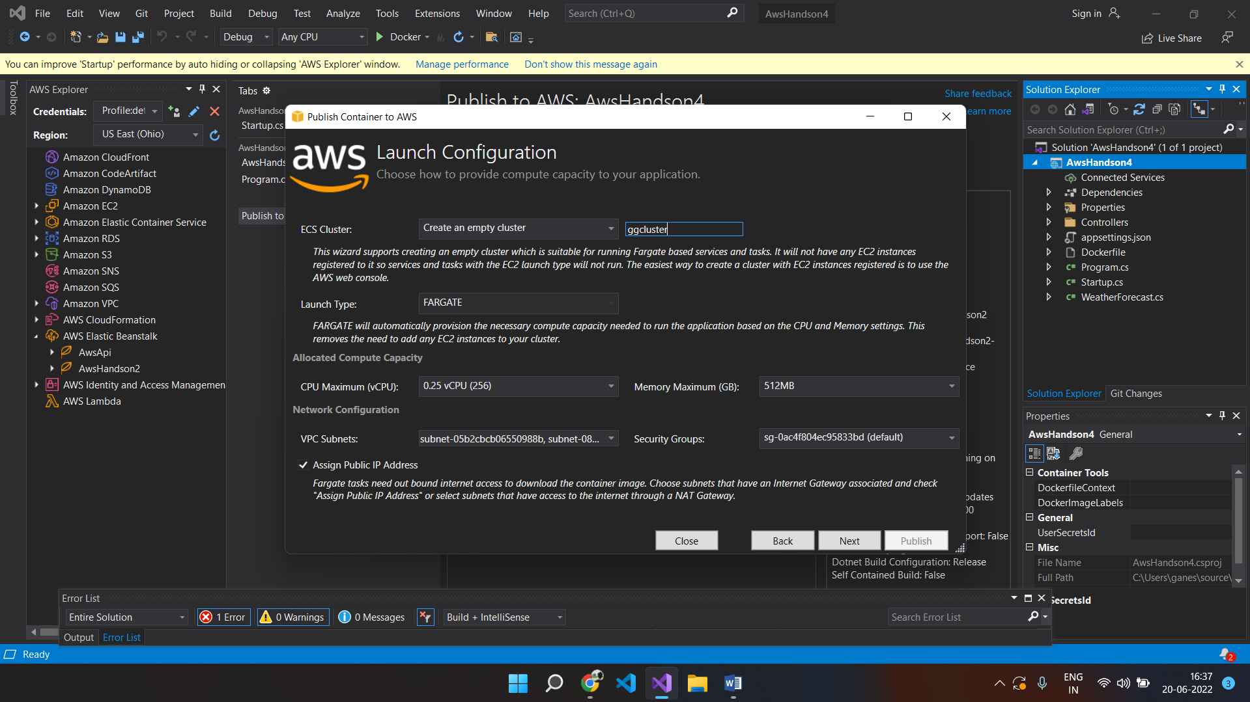

1. Click on Next and choose number of tasks and give a name to the task group as shown below:

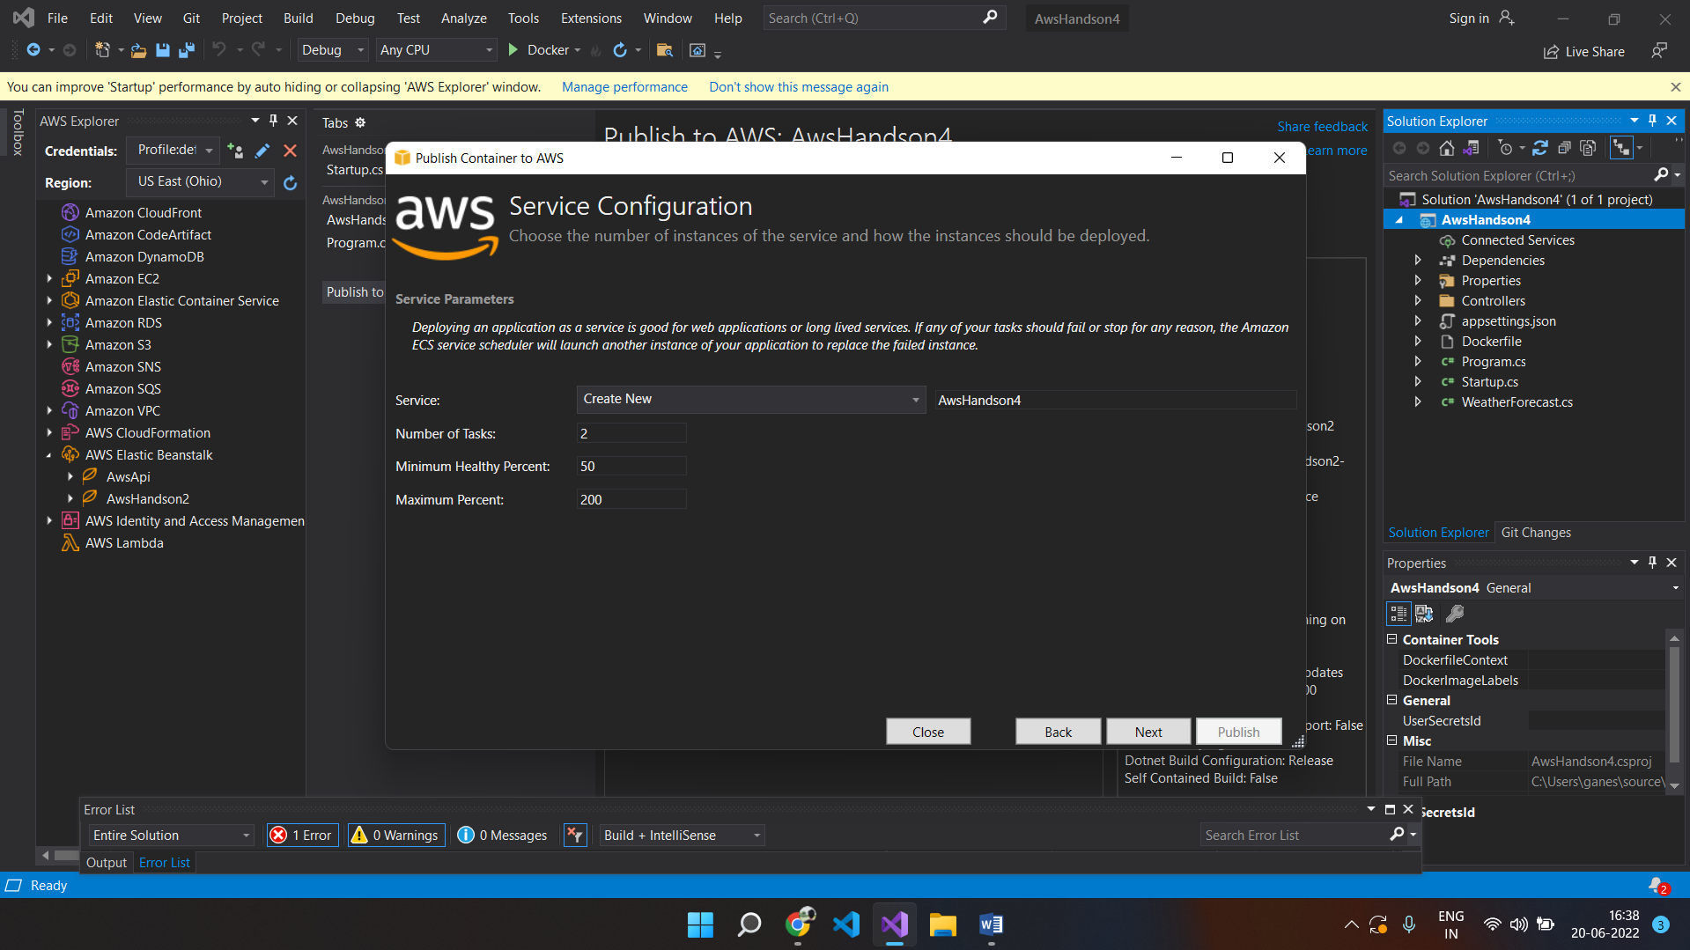

1. In the next screen, choose to create new Task Definition and choose the Task Role as “PowerUserAccess” and click on publish.

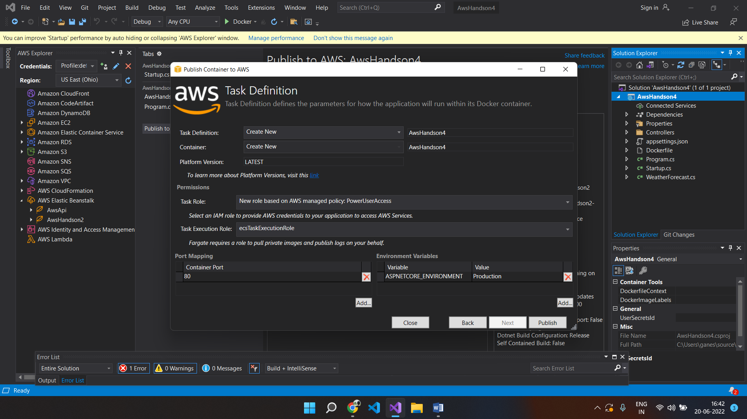

1. The following screen will appear

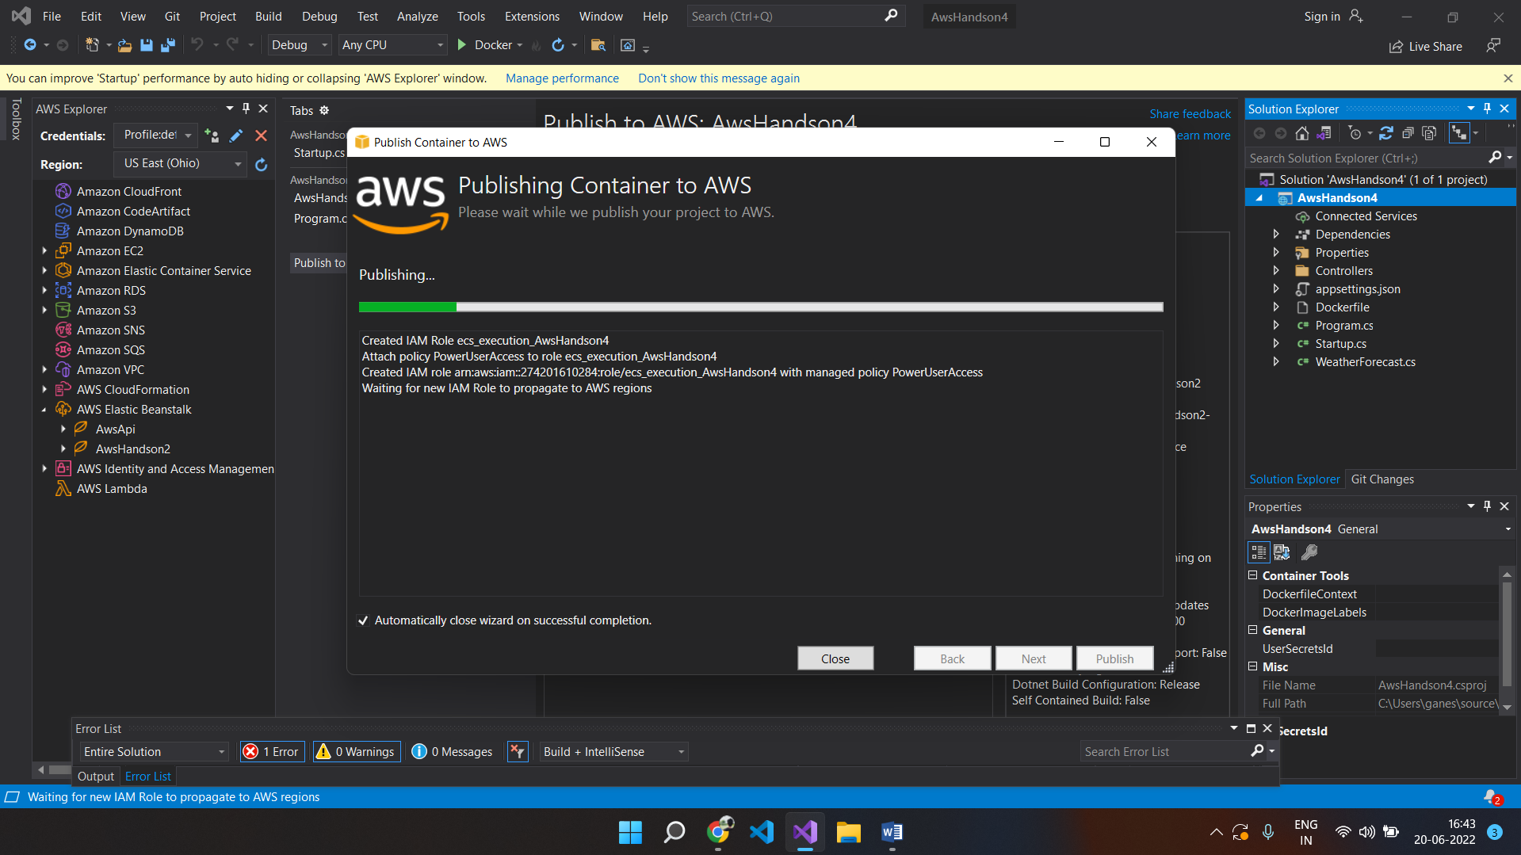

1. The docker image is getting pushed to ECS

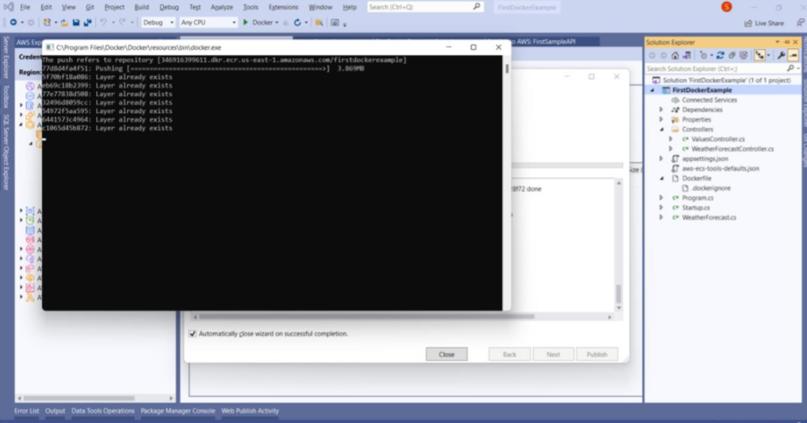

7. Go to the portal and search for ECS in the services

8. The following screen will appear

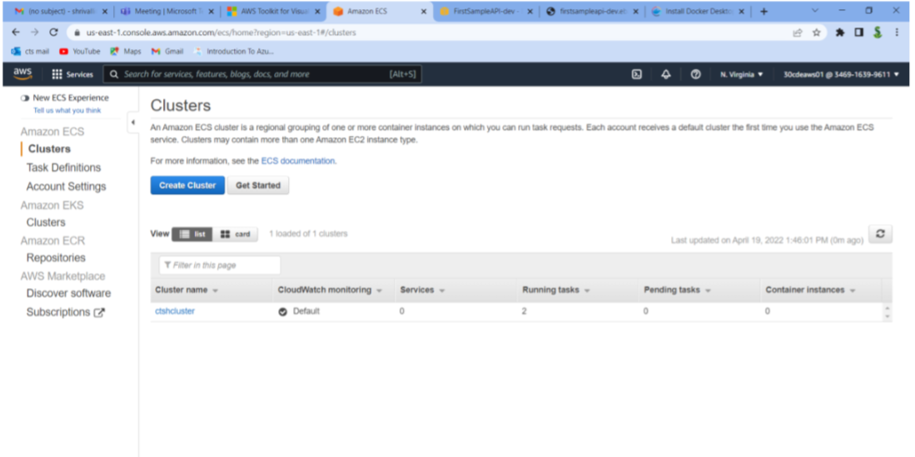

9. Click on cluster and click on Tasks to get the following screen where 2 tasks are running

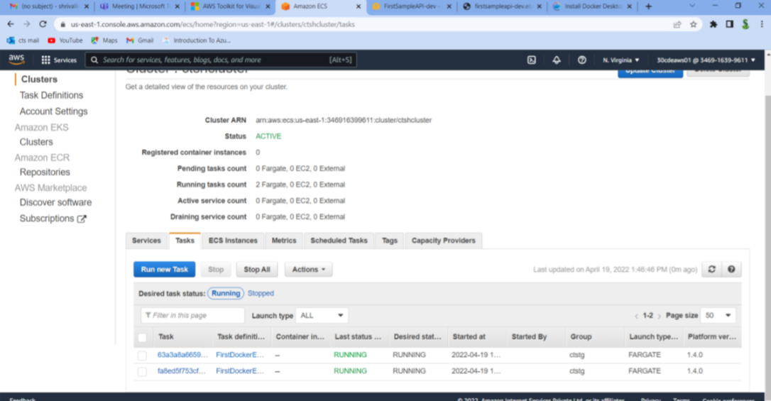

10. In Aws Explorer, click on Clusters and choose our cluster and click on tasks to get the public IP address where the endpoint can be accessed.

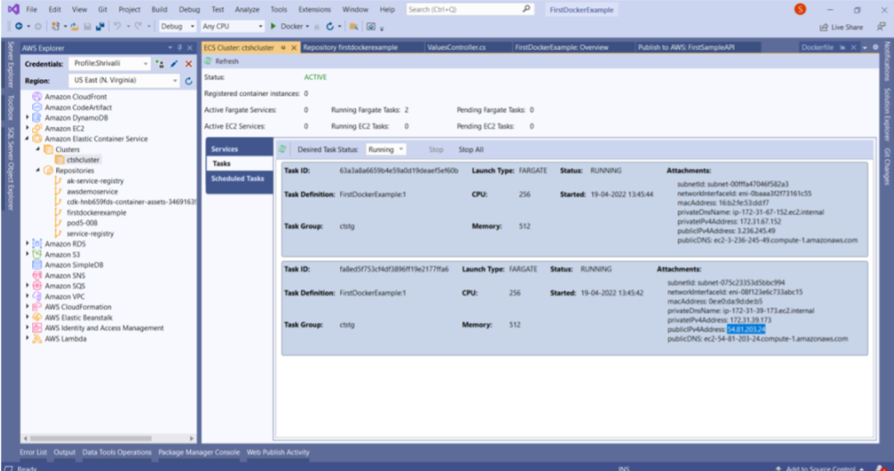

11. Browse the Url with that end point to get the image running on ECS as shown below:

